AMPD Expo
Audio & Music Producers & Developers Exposition
as part of the
6th Annual Triad Music Festival

Saturday, September 2rd, 2017

Milton Rhodes Center for the Arts
251 N Spruce Street
Winston-Salem, North Carolina

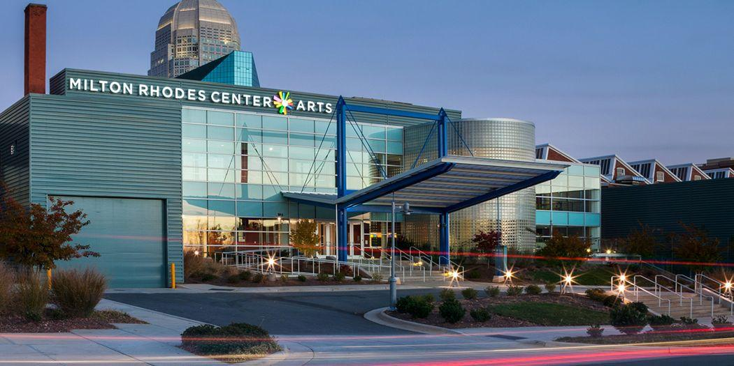

Food Trucks, Live Music, Demo & Pitch Sessions, Workshops, Panelists, Vendors,
and Pro Audio & Instrument Exhibitors!

Presented by SoundLizzard Productions, LLC

Fee Schedule:

- $85.00 – Pro Exhibition Booth (pro gear and music only)
  - 8’ x 10’ carpeted booth area
  - One 8’ skirted and clothed table
  - Pipe and Drape separating from other booths
  - 2 chairs
  - Power to booth
  - Premium Location
  - Access to utilize credit card station for transactions
  - If signed up by July 31st: will have a chance to earn cross promotion through New Bay Media (Pro Sound News, Pro Audio Review, Mix, Sound & Video Contractor, Electronic Musician, etc.) via online banner ads as well as on a marquis banner mounted on the side of the building promoting the festival. Logos will need to be submitted to info@soundlizzard.com by July 31st.

- $50.00 – Demo Slot or Pitch Session (pro gear and music only)
  - Demo Slot: Scheduled 20 minute demo in the exhibit hall when other exhibitors will not make noise and your exhibit becomes the focus of the hall. Must schedule this before August 10th
  - Pitch Session: A 30 minute scheduled session in a private room for a group of up to 25 people.
  - Demo Slots & Pitch Sessions will be advertised in the schedule to guests when they walk in and in the playbills and advertising prior to the Expo.
  - Only available with Pro Exhibition Booths.

- $50.00 – Company Booth (local or regional gear, music, or similar industry)
  - Designed for local retailers or service providers who plan to sell little, are advertising a service, or do not need a Pro Exhibition Booth.
  - One 8’ skirted and clothed table
  - 1 chair
  - 9’ x 4’ carpeted area, not divided between booths

All Pro Exhibitors and Company Booths will be featured in our playbill, fliers, newsletter and press releases, and in any pre-festival reviews, if received by July 31st.

- $35.00 – Independent Vendor Booth
  - Designed for local crafts, apparel, etc. (no food/drink sales)
  - 6’ table (no skirt or cloth)
  - All vendors will be set up in the Marketplace area

- 10% Commission – Gear Swap
  - Individuals who want to sell a piece of equipment, accessory, instrument and do not have need for a booth.
  - Up to 3 items per person can be checked in at the Gear Swap. If you need to bring more items than 3 you may purchase a table.
  - Check in your item(s) any time during the Exhibit Hall times (no earlier than 11am) and check out any time before 4pm (closing time).
  - Staff will manage the Gear Swap area and sales based on desired price by seller
  - Festival will retain 10% of commission ONLY if the item sells. If the item does not sell, the buyer does not owe any fees.

If you are not clear as to which booth you should sign up for please contact us at info@soundlizzard.com.

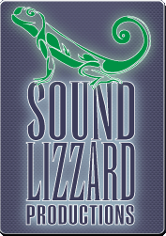
About:
The Triad is home and birthplace to a wealth of amazing musicians and songwriters and the music scene is growing faster than the industry can keep up. SoundLizzard Productions plays a key role in the community by assisting musicians with project coordination and music production. SoundLizzard Productions is committed to showcasing and celebrating local artists through the Triad Music Festival, a weekend celebration that was started in 2012.
The event has expanded exponentially – now in its 6th year – and includes performances at multiple venues, networking and educational opportunities, exhibits and vendors, and is supported by a strong arts community. There are many things offered for the engineer, technician, musician, and music lover. The festival is designed to bring awareness to performing songwriters and support local and regional companies in this industry.
The Expo is hosted in Winston-Salem, which has the oldest Arts Council in the country, because it is centrally located between Washington D.C., Atlanta, and Nashville. Attendees travel from as far as Nashville and includes major producers/engineers, studio owners, venue managers, universities and colleges from cities such as Charlotte, Raleigh, Asheville, Boone, Greensboro, and Chapel Hill. It is easily accessible across the region and will continue to expand its reach.

Schedule:

Thursday, August 31st - Delurk Gallery – Kick Off Party
7p-10p Songwriter Stand-Off: songwriters will have a chance to sign up to perform on stage in this competition-style open mic. Winner takes home 50% of entry fees.

Friday, Sept 1st – Hanesbrands Theatre – Mainstage
6p-7p VIP Dinner with the Band
8p-11p Lonesome River Band

Saturday, Sept 2nd – Milton Rhodes Center for the Arts/ Winston Square Park – AMPD Expo
11a-4p Pro Audio Exhibitors, Music & Gear Retailers/Manufacturers, Gear Swap (Buy, Sell, Trade), Vendor Marketplace, Food Trucks, Demo & Pitch Sessions
1p-3p Studio & Live Sound Panels; Tech & Musician Workshops
11:30a-1p Music in the Park featuring Vagabond Saints Society
7p-11p Industry Parties

Sponsorship & Advertisement Opportunities

Past Sponsors, Partners, and Contributors: Underdog Records, The Garage, Studio B Mastering, SECCA, Dueling Butterknives, First in Flight Entertainment, Forte Music, Nu Expression, Doodad Farm, District Rooftop Bar & Grille, Yes! Weekly, Realizzation Records, Brookstown Inn, Willow’s Bistro, Ziggy’s, Community Arts Café, Foothills Brewery, Small Batch Brewery, Quiet Pint, Dichotomy Entertainment, Muse Scenic, NSAI, Old Winston Social Club, Black Mountain Chocolate, Clubhouse, Triad City Beat, Susan G. Komen Race for the Cure, Forsyth County Entertainment Awards, PreSonus, Pro Sound News, Hoots Beer Company, Delurk Gallery, Imagine Design & Production Services, The Less Desirables, O’Kelly Design Studios, Camel City Dispatch, Slingshot Marketing Group, Across the Horizons, Wo Imaging, Coffee Park

Exclusive Title Sponsor ($1000 and up) Sponsors an event
Billed as title sponsor in event title; i.e. “Triad Music Festival presented by SoundLizzard Production, and in part by _________________.”
- Incorporate presenting sponsor in on-stage introductions
- Logo printed on playbill; all media materials such as fliers, banners, t-shirts; in tandem with the TMF logo, all press and publications
- Additional advertising via news, radio, print, outdoor, and interned ads with mention of title sponsor
- Logo advertised on the Triad Music Festival website with link to website
- Premium on-site sponsor signage (signs must be pre-approved)
- Company booth at the NC Regional Music & Gear Exhibition
- 8 VIP Badges giving access to ALL shows with VIP seating and access to VIP parties and activities
- Additional tickets available at discounted rates for Mainstage Show

Headline Sponsor ($300-$999) Sponsors a band performing at the festival
- Logo printed on playbill, all media materials, in tandem with the Triad Music Festival Logo, all press and publications
- Additional advertising via news, radio, print, outdoor, and interned ads with mention of headline sponsor
- Logo advertised on the Triad Music Festival website with link to website
- Premium on-site sponsor signage (signs must be pre-approved)
- Company Booth at the Mainstage Show
- 4 VIP badges giving access to ALL shows with VIP seating and access to VIP parties and activities
- Additional tickets available at discounted rates for Mainstage Show

Contributing Sponsor ($100-$299) Sponsors expenses for the festival
- Logo or Name printed in playbill and all media materials promoting the festival
- Name is listed on the Triad Music Festival website
- 2 VIP badges giving access to ALL shows with VIP seating and access to VIP parties and activities

Donors & Underwriters ($99 and below) Sponsors expenses for the festival
- Listing as a donor in the Triad Music Festival weekend playbill

Playbill Advertisements
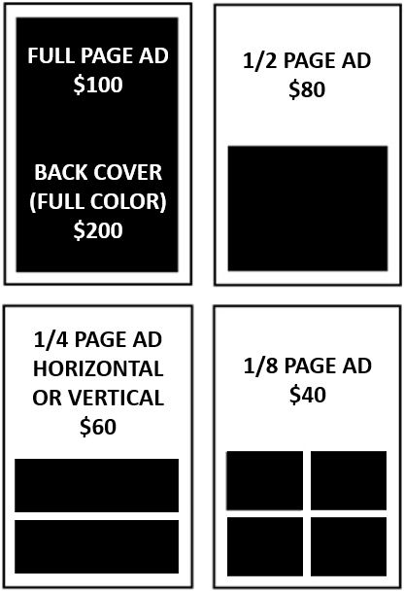
1/8 page ad: $40 1/4 page ad: $60 (Horizontal or Vertical) 1/2 page ad: $80 Full page ad: $100 Back Cover (full color): $200
Specifications - All ads MUST be submitted in digital form (pdf files are preferred) or as camera-ready art
Please submit to: info@soundlizzard.com - All color ads must be submitted in a high quality digital form (300 dpi resolution) (pdf or png files are preferred).

Rules & Guidelines for Participating in the NC Regional Music & Gear Expo
- All deposits and fees must be paid when registering for a booth. This fee is to be paid either via PayPal or by check mailed to 213 W 6th Street, Winston-Salem, NC 27101. Your booth will not be reserved until payment is received in full. If paying via paypal you may look up our account: SoundLizzard Productions -- or by email: paypal@soundlizzard.com. Please pay the full amount due at one time.
- Exhibitors and Vendors are allowed to sell items if they choose to. There will be wireless available for vendors. Vendors are responsible for keeping track of their own cash box. Pro Exhibition and Company Booths should provide their own way for sales, however, the Gear Swap area will have a Square account that can be used and payout will occur at the close of the Exhibit Hall. Processing Fees may apply.
- Exhibitors may place signs on their table or the floor. Nothing can be taped, pinned, zip-tied, or Velcro-ed to the pipe and drape. Signs can be tied off using tie line, hooks to hang from pipe, or floor mounted.
- Exhibitors may begin arriving at 9am. The Exhibit Hall opens to the public at 11am. All exhibitors and vendors must be set up prior to the opening of the Exhibit Hall. Exhibit Hall closes at 3pm. Vendors and Exhibitors must stay for the duration and are not allowed to leave until 3pm. Exhibitors have until 4pm to clear the area of all items.
- Pro Exhibition Booths and Company Booths are given a VIP badge to attend other VIP activities throughout the weekend. You will receive separate information on these activities.
- All boxes, cases, and other non-display items must be stored neatly under exhibit table. Large road cases and similar sized boxes can be stored in a separate area upon request.
- Gear Swap items cannot be junk items. If there are any known issues with an item, there must be a description of the product provided during check-in. The item must be related to music, audio, lighting, video, or other similar category. It is at the discretion of the Gear Swap staff as to whether an item meets the qualifications to be sold.
- Gear Swap space will be provided based on a first-come, first-serve basis until space runs out. If you are concerned about reserving space, a vendor table might be a better option.
- All Gear Swap items must be owned by the individual checking in. Any items not picked up at the end of the Exhibit Hall hours becomes the property of Triad Music Festival. Please make sure to pick up your items!
- No vendors are allowed to set up their own table, move their table location, or block other vendors spaces. Vendors and Exhibitors are only approved to be within their booth location.
- Sponsors and Donors are asked to write a check and mail to 213 W 6th Street, Winston-Salem, NC 27101 and state their Sponsor category. Trade sponsorships are also available upon request.

Contact: Liz.May@SoundLizzard.com 336.608.6138 www.triadmusicfestival.com

